

ICT Lab
BS CYFS 2025
Assignment # 3
Name: Ibrahim Bin Arif
Roll no: 2503541

Submitted to : Mrs. Laraib Javaid

Creating My own small portfolio type website:
Code:
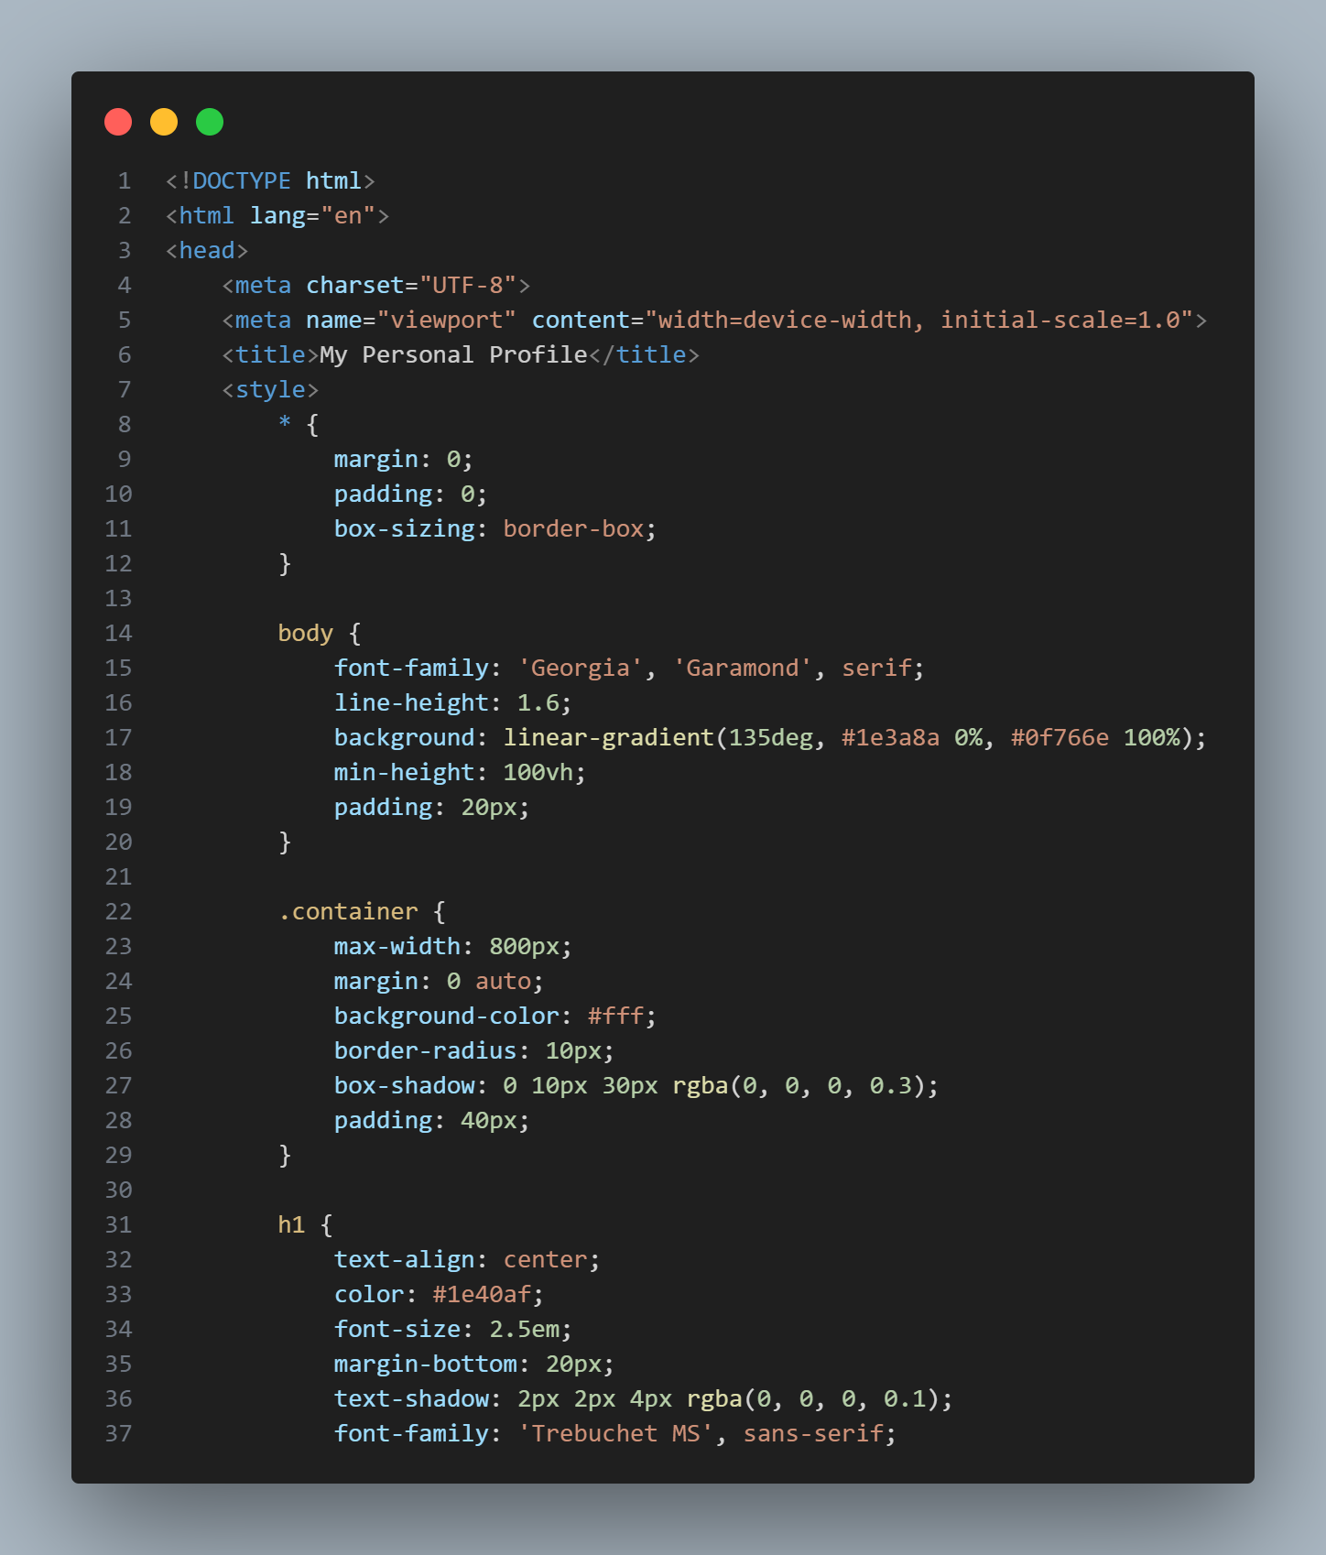
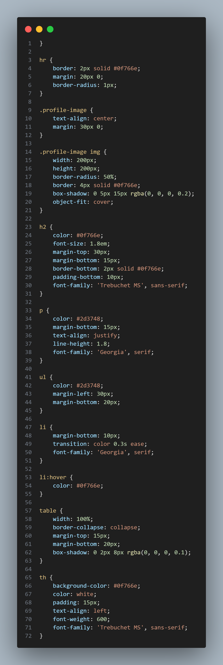
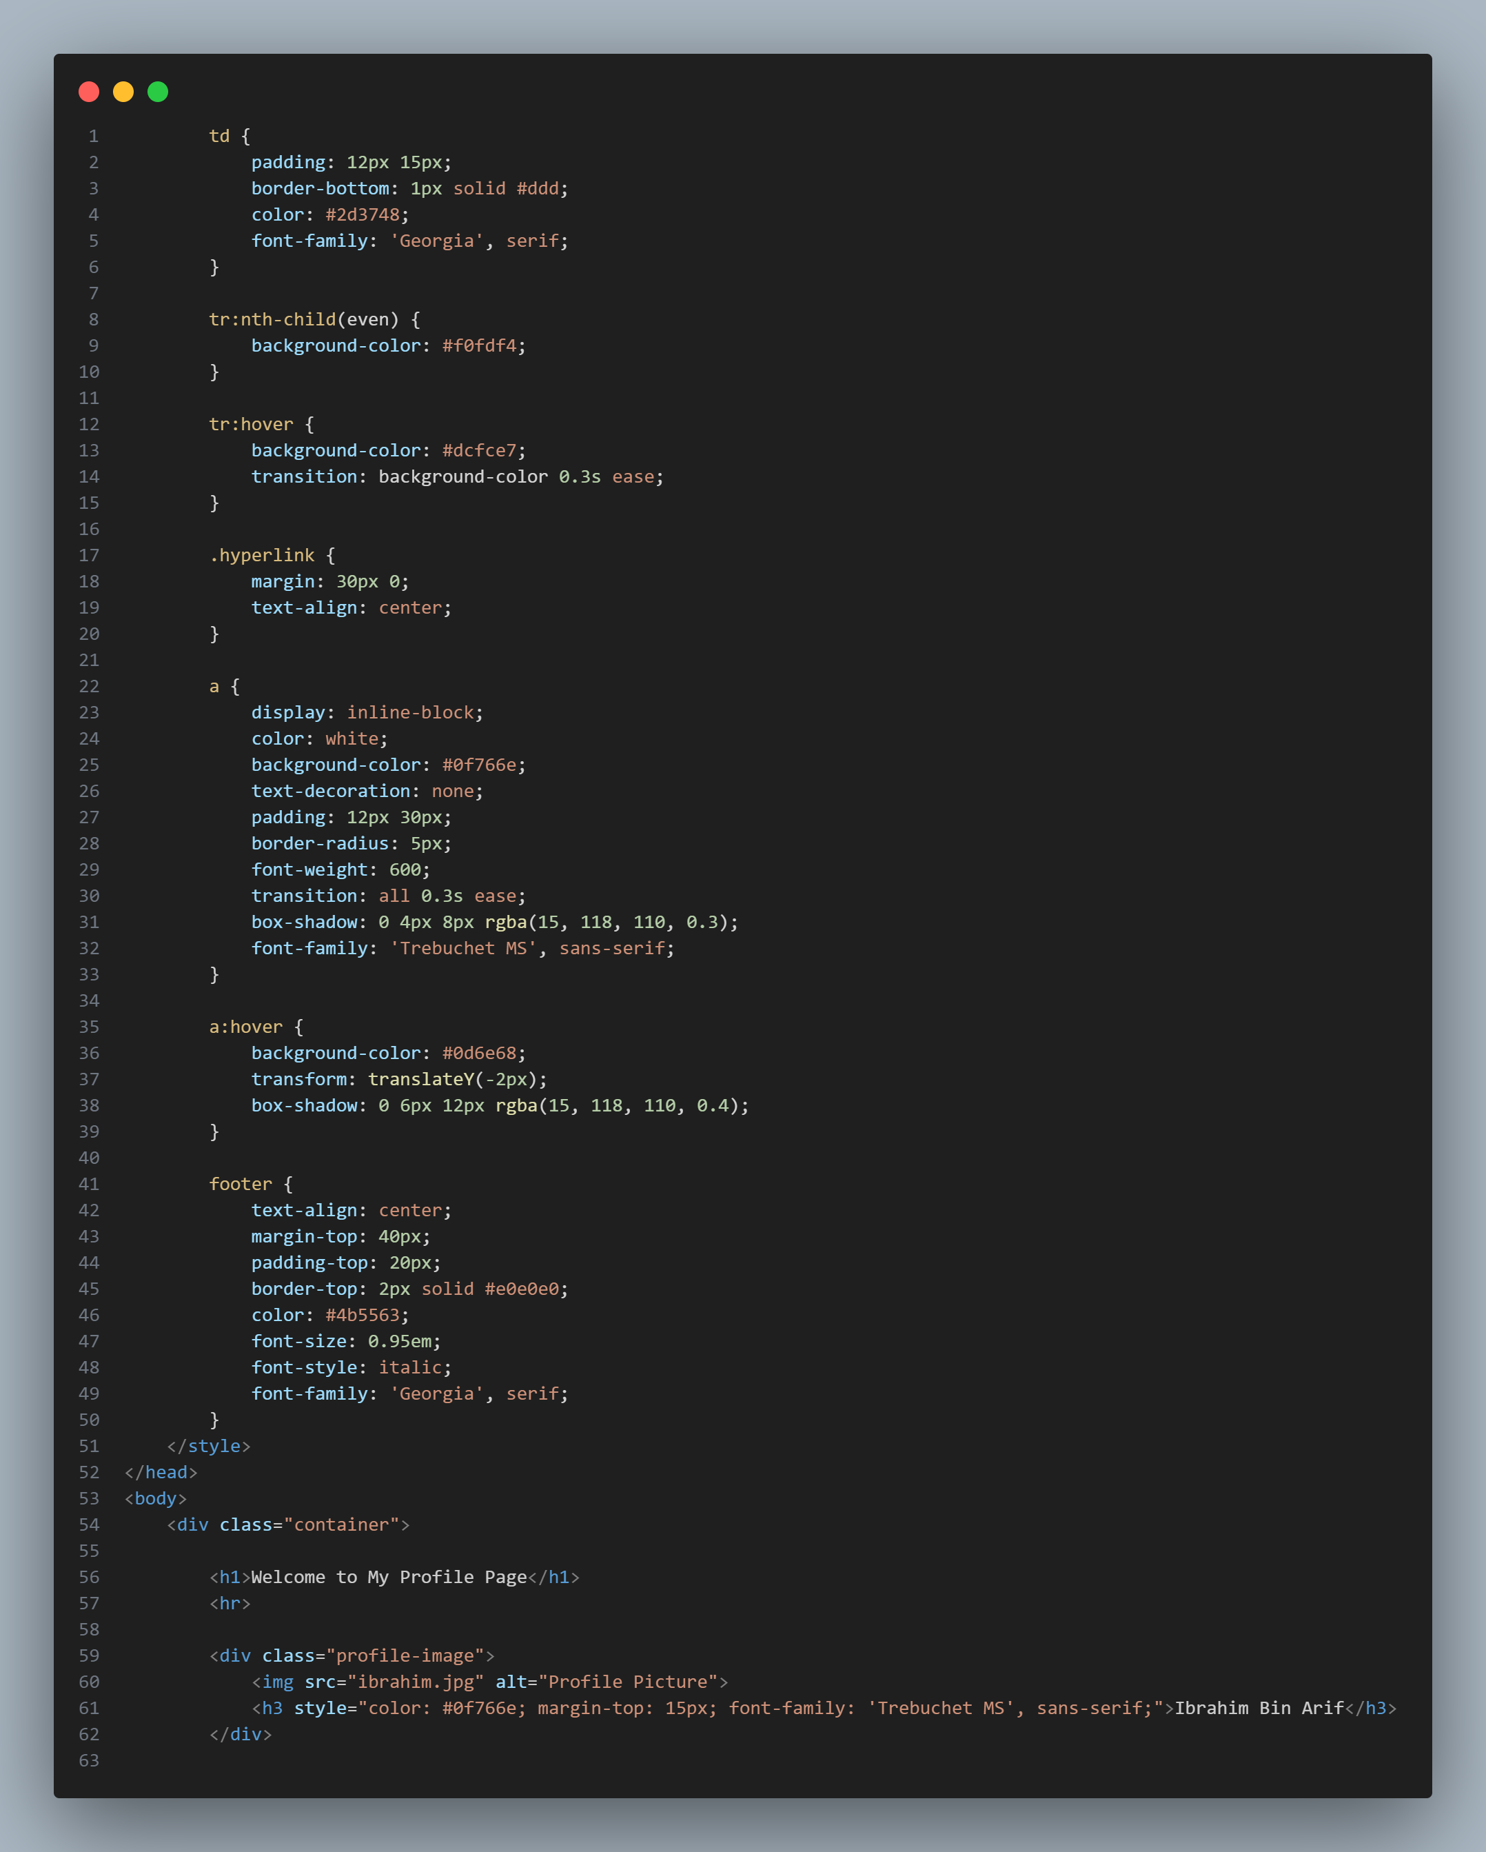
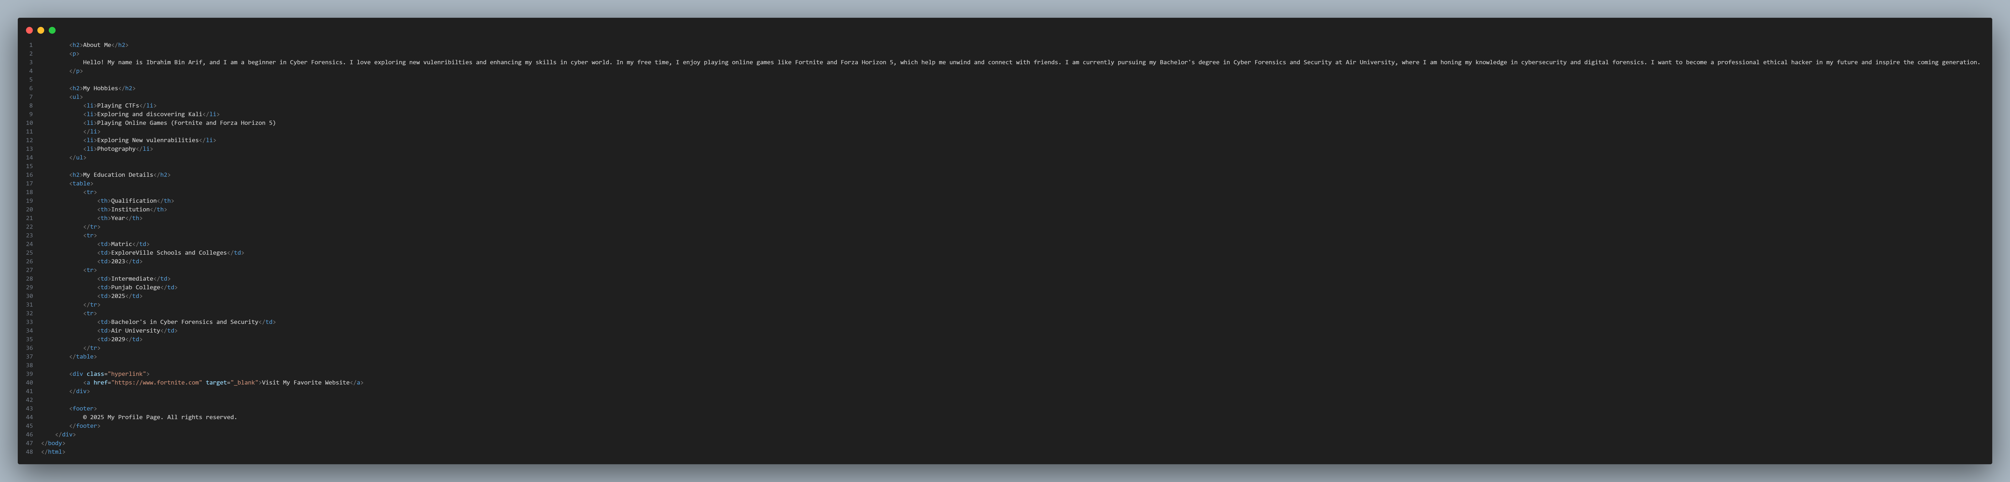
Output:
